ASSIGNMENT 1 - SHIELDS UP/ HAVE I BEEN PAWNED

SHIELDS UP
Question 1: what did I do?
I accessed the Gibson Research Corporation website (grc.com) and selected their well-known security utility called Shields Up. This tool is specifically designed to test system vulnerabilities by probing the open ports on a device connected to the internet. Once I launched the scan, the site automatically identified my computer’s IP address and initiated a series of checks across a range of common ports as well as all ports. The results provided a clear overview of which ports were visible, closed, or operating in stealth mode, giving me insight into the overall security posture of my laptop.
Question 2: what were the results?
The results of the scan were outstanding and far exceeded my expectations. The analysis revealed that not only the 26 common ports, but also all 1,056 service ports on my system, were operating in full ‘stealth’ mode rather than simply being open or closed. This stealth status is significant because it means that my system did not respond to any of the probing attempts—no unsolicited packets were acknowledged, and no ping or ICMP echo requests were permitted to pass through. In practical terms, this makes my laptop virtually invisible to external attackers who might be scanning for vulnerabilities. The absence of detectable ports greatly reduces the risk of intrusion and demonstrates a strong security. Considering that this is a personal laptop containing sensitive files, personal communications, and personal information (PIIs), I found these results reassuring. It provided confidence that my device is well-protected against common network-based threats.
COMMON PORTS – TEXT SUMMARY
-----------------------------------------------------------------

GRC Port Authority Report created on UTC: 2025-09-06 at 18:53:41

Results from scan of ports: 0, 21-23, 25, 79, 80, 110, 113,
119, 135, 139, 143, 389, 443, 445,
1002, 1024-1030, 1720, 5000

0 Ports Open
0 Ports Closed
26 Ports Stealth
---------------------
26 Ports Tested

ALL PORTS tested were found to be: STEALTH.

TruStealth: PASSED - ALL tested ports were STEALTH,
- NO unsolicited packets were received,
- NO Ping reply (ICMP Echo) was received.

----------------------------------------------------------------------
ALL SERVICE PORTS – TEXT SUMMARY
----------------------------------------------------------------------

GRC Port Authority Report created on UTC: 2025-09-06 at 18:57:42

Results from scan of ports: 0-1055

0 Ports Open
0 Ports Closed
1056 Ports Stealth
---------------------
1056 Ports Tested

ALL PORTS tested were found to be: STEALTH.

TruStealth: PASSED - ALL tested ports were STEALTH,
- NO unsolicited packets were received,
- NO Ping reply (ICMP Echo) was received.

----------------------------------------------------------------------
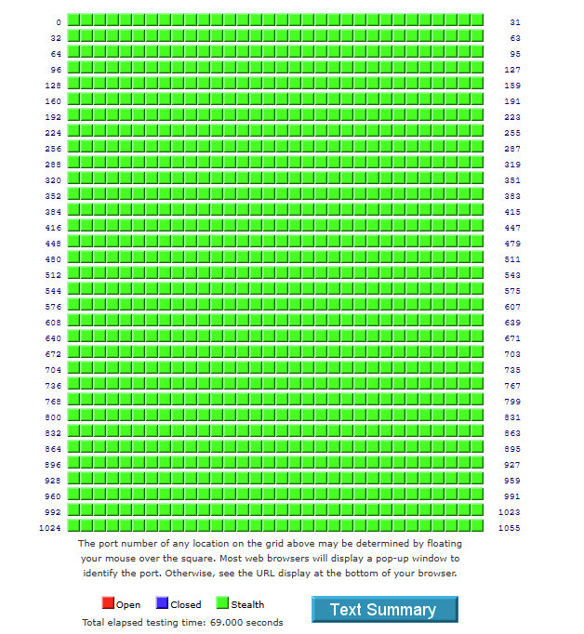

Question 3: What did I learn?
This exercise highlighted the importance of proactively checking the security status of personal devices. By using the Shields Up tool, I was able to confirm that my laptop is effectively shielded from unsolicited external access, which provides peace of mind given the amount of personal and sensitive information it holds. The key takeaway from this assignment is that even though most users may assume their devices are secure, running an actual vulnerability scan provides tangible evidence of their protection level. I learned that maintaining strong default configurations, combined with firewalls and proper network settings, can make a device virtually invisible to attackers. This reinforced the broader lesson that cybersecurity is not just about installing software, it is about regularly testing and verifying defenses to ensure ongoing protection.

HAVE I BEEN PAWNED
Question 1: what did I do?
For this part of the assignment, I used the “Have I Been Pwned” website, a widely recognized tool for identifying whether email addresses have appeared in known data breaches. I tested three of my email accounts—two personals (one dating back to my teenage years and another created about ten years ago) as well as my office email address. I also inputted four of my passwords to check their vulnerabilities and strengths.
However, I noticed that the site no longer supported checking phone numbers, which may be a recent update.

Question 2: what were the results?
To my relief, the tool returned a green checkmark for all of them, indicating no breaches were found. This meant that none of my email addresses had appeared in any known data leaks, and the vulnerability check passed with flying colors.
After confirming that all three of my email addresses were safe, I decided to check four of my frequently used passwords as well. Fortunately, each of these passwords, which I use for my email, banking information, and laptop logins, also returned green checkmarks indicating that they had not been compromised in any known breaches. This gave me additional assurance that my commonly used credentials remain secure.

EMAIL ADDRESSES CHECK
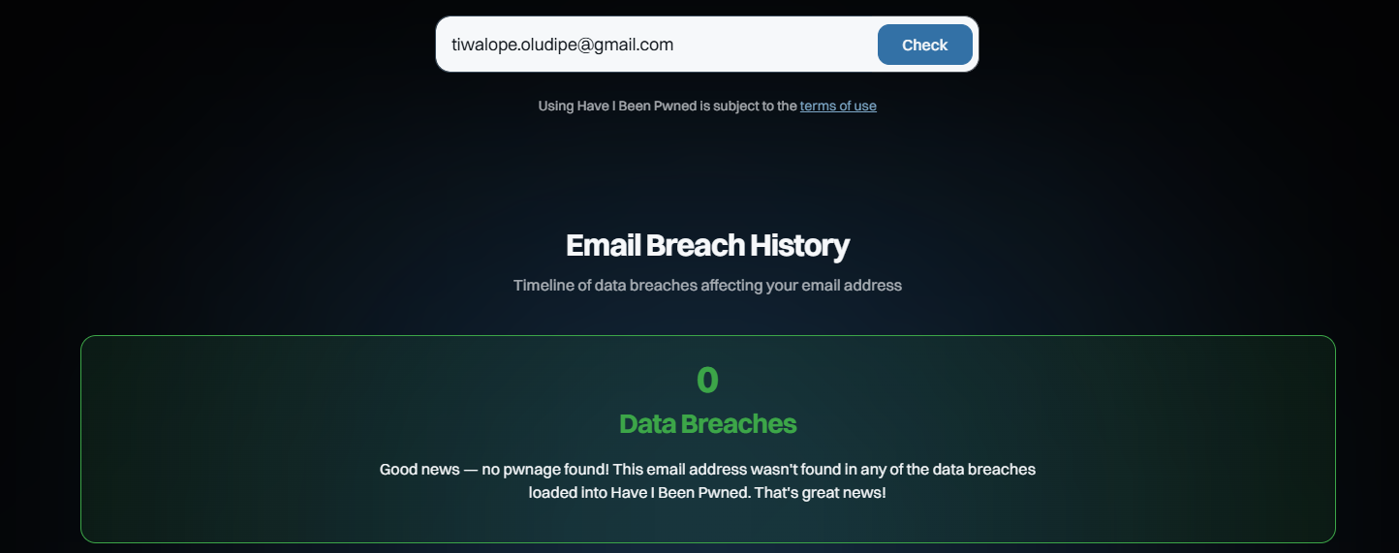
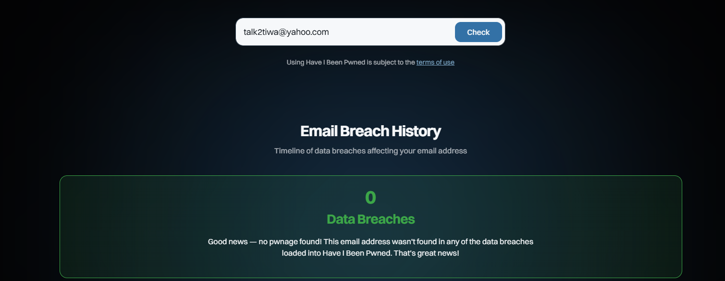
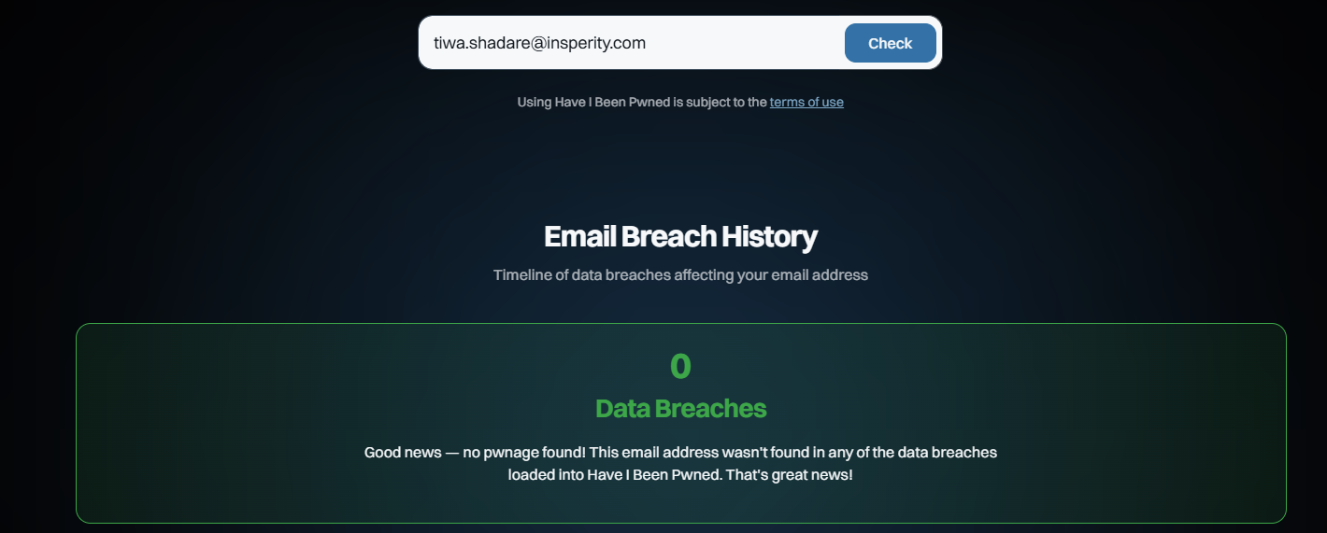

PASSWORD CHECKS
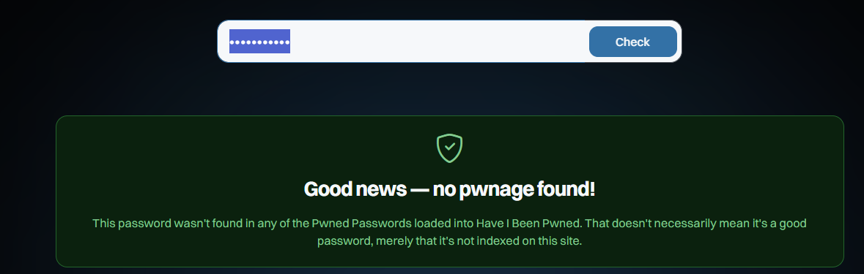
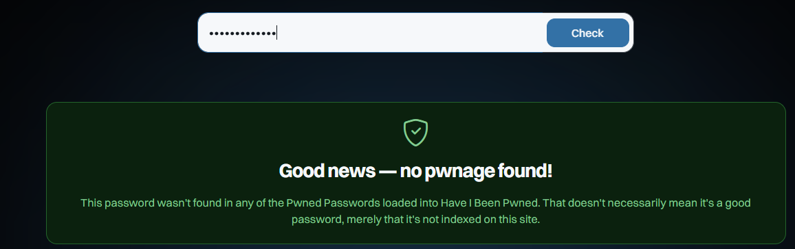
Question 3: What did I learn?
This exercise reinforced how vital it is to periodically check the exposure status of both emails and passwords. While it may seem like a minor precaution, conducting these checks provides early warning signs that credentials may have been compromised in past data breaches. By identifying potential exposures promptly, users have the opportunity to change their passwords, enable multi-factor authentication, and take other protective steps before attackers can exploit the information. In this way, a simple and routine action (such as running an email or password check) serves as a powerful preventive measure that can make a significant difference in maintaining overall digital security and reducing the likelihood of identity theft or unauthorized access.

